Non-Uniform Repeated Components

Definition
# Source: AI Source: Provided by: [Data Path: Persons Table -> ID Column: 1, Name_En Column: Motasem Essam] -> From: [ChatGPT] on [7/25/2026]
Non-uniform repeated components are composite-solid components formed by repeating geometric solids without maintaining one consistent dimensional pattern across all repetitions.
The components generally belong to the same geometric category, but their dimensions may vary irregularly or according to changing relationships.
Their variations may include:
- Different lengths, widths, and heights.
- Different radii and heights.
- Irregularly increasing or decreasing dimensions.
- Unequal scale factors.
- Irregular dimensional sequences.
- Different combinations of dimensional values.
For example, a composite solid made by joining cubes with side lengths of 2 cm, 3 cm, 5 cm, and 4 cm has non-uniform repeated components because their dimensions do not follow a constant difference or ratio.

Simple Definition
# Source: AI Source: Provided by: [Data Path: Persons Table -> ID Column: 1, Name_En Column: Motasem Essam] -> From: [ChatGPT] on [7/25/2026]
A composite solid formed by repeating components of the same geometric category but with dimensions that do not follow one consistent dimensional pattern.

Geometric Representation
# Source: AI Source: Provided by: [Data Path: Persons Table -> ID Column: 1, Name_En Column: Motasem Essam] -> From: [ChatGPT] on [7/25/2026]
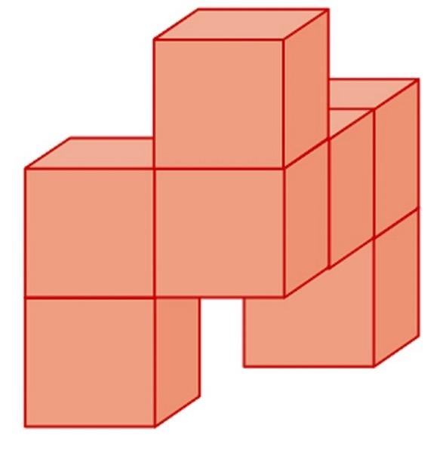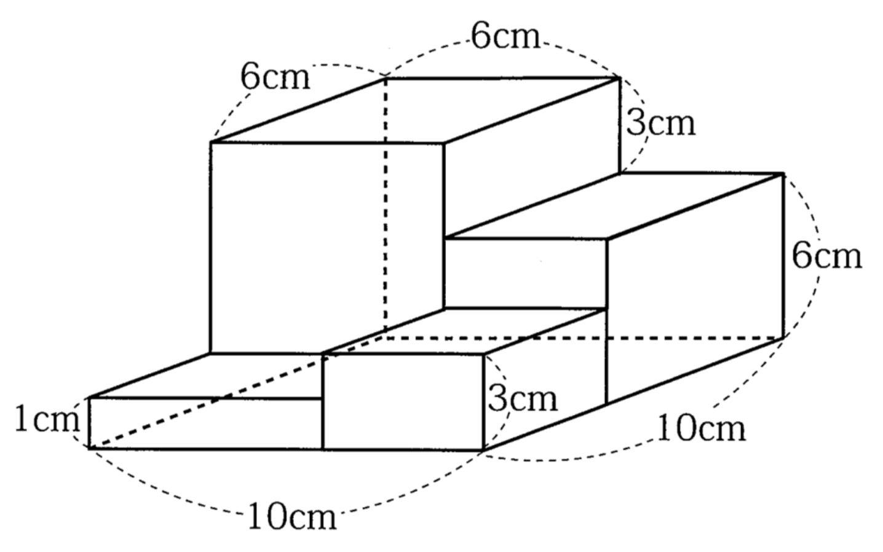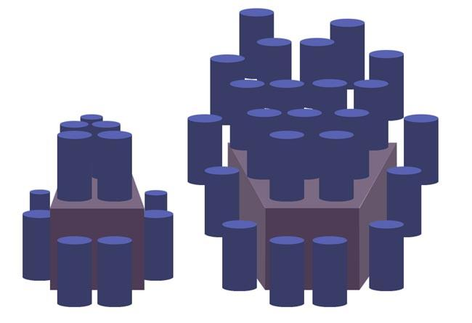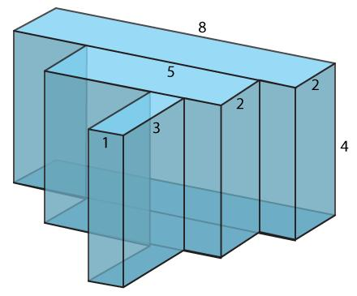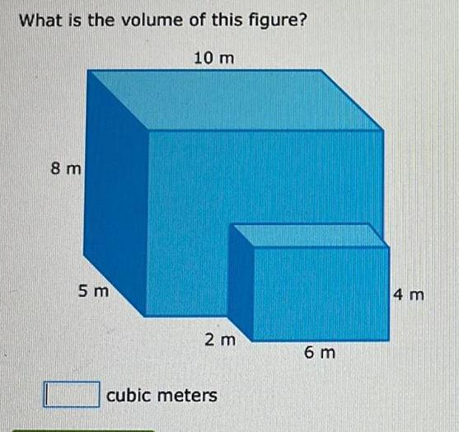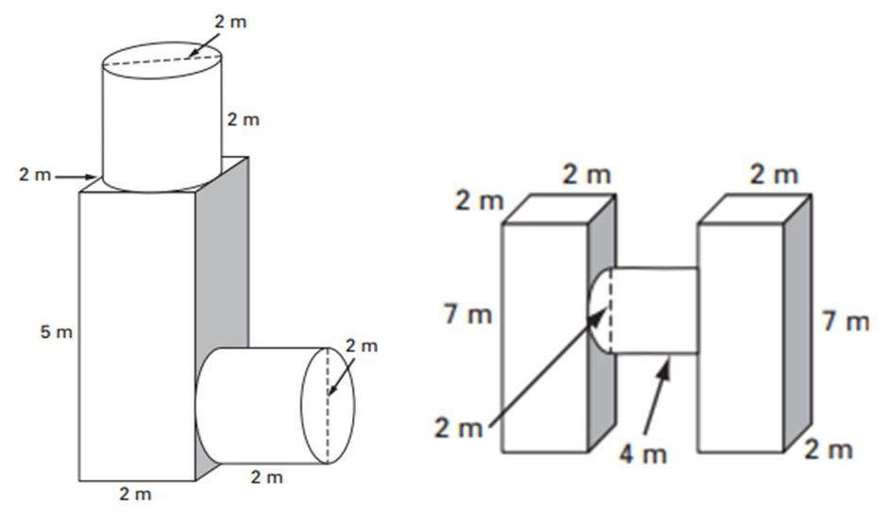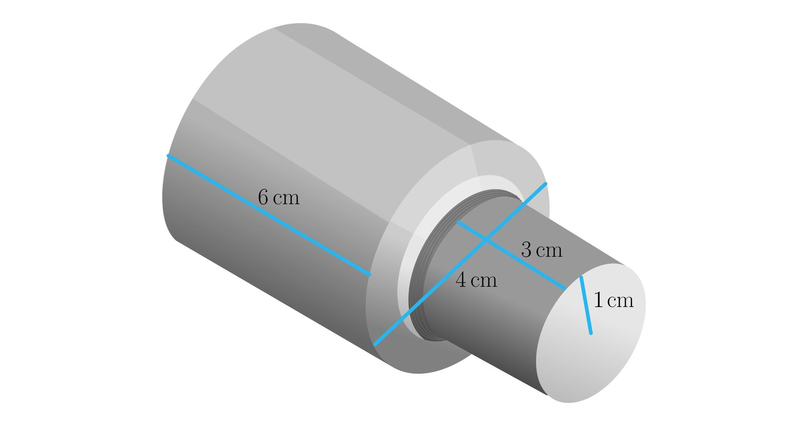
These examples illustrate repeated components with varying dimensions and no necessary regular size progression.

Main Classification
# Source: AI Source: Provided by: [Data Path: Persons Table -> ID Column: 1, Name_En Column: Motasem Essam] -> From: [ChatGPT] on [7/25/2026]
Non-uniform repeated components can be classified according to the geometric shape being repeated.

Non-Uniform Repeated Cubes
# Source: AI Source: Provided by: [Data Path: Persons Table -> ID Column: 1, Name_En Column: Motasem Essam] -> From: [ChatGPT] on [7/25/2026]
- All components are cubes.
- Their side lengths vary irregularly.
- Their volumes and surface areas differ.
- They may be arranged in irregular rows, layers, or clusters.
For component $i$, with side length $s_{i}$:
$$V_{i}=s_{i}^{3}$$
$${SA}_{i}=6s_{i}^{2}$$

Non-Uniform Repeated Rectangular Prisms
# Source: AI Source: Provided by: [Data Path: Persons Table -> ID Column: 1, Name_En Column: Motasem Essam] -> From: [ChatGPT] on [7/25/2026]
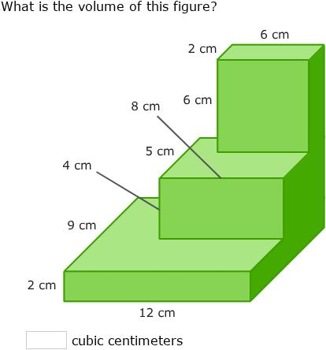
- All components are rectangular prisms.
- Their lengths, widths, and heights may vary independently.
- Their proportions may differ.
- Their joining faces may have different dimensions.
$$V_{i}=l_{i}$$
$${SA}_{i}=2(l_{i}+l_{i}+w_{i})$$

Non-Uniform Repeated Cylinders
# Source: AI Source: Provided by: [Data Path: Persons Table -> ID Column: 1, Name_En Column: Motasem Essam] -> From: [ChatGPT] on [7/25/2026]
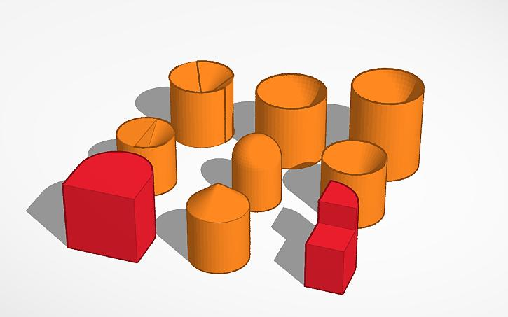
- All components are cylinders.
- Their radii and heights may vary irregularly.
- Their axes may have different orientations.
- They may be arranged in irregular stacks or groups.
$$V_{i}=πr_{i}^{2}h_{i}$$
$${SA}_{i}=2πr_{i}(r_{i}+h_{i})$$

Non-Uniform Repeated Cones
# Source: AI Source: Provided by: [Data Path: Persons Table -> ID Column: 1, Name_En Column: Motasem Essam] -> From: [ChatGPT] on [7/25/2026]
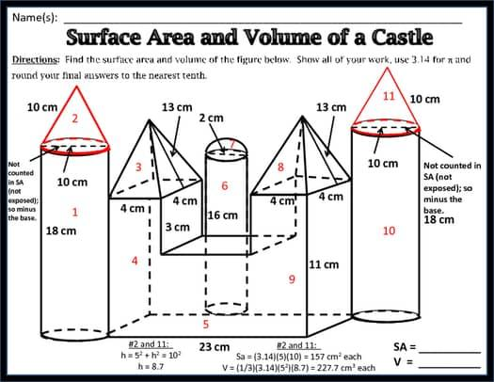
- All components are cones.
- Their base radii and perpendicular heights may vary.
- Their slant heights may also differ.
- Their sizes do not need to follow a consistent progression.
$$V_{i}=\frac{1}{3}πr_{i}^{2}h_{i}$$

Non-Uniform Repeated Pyramids
# Source: AI Source: Provided by: [Data Path: Persons Table -> ID Column: 1, Name_En Column: Motasem Essam] -> From: [ChatGPT] on [7/25/2026]
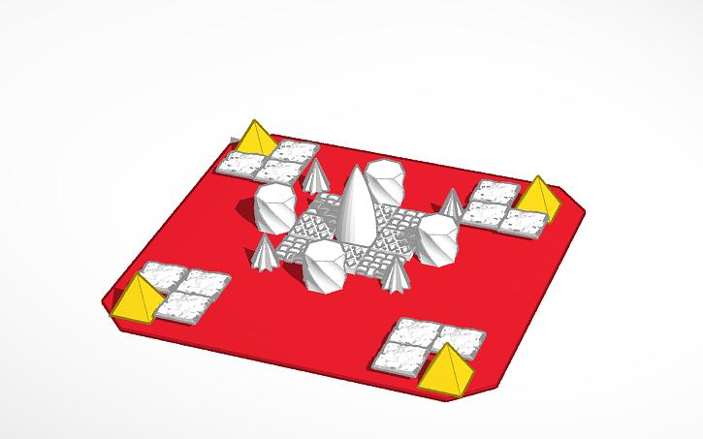
- All components are pyramids of the same geometric type.
- Their base dimensions and heights may differ irregularly.
- Their individual volumes and surface areas may vary.
- They may be arranged in irregular layers or groups.
$$V_{i}=\frac{1}{3}B_{i}$$

Non-Uniform Repeated Spheres
# Source: AI Source: Provided by: [Data Path: Persons Table -> ID Column: 1, Name_En Column: Motasem Essam] -> From: [ChatGPT] on [7/25/2026]
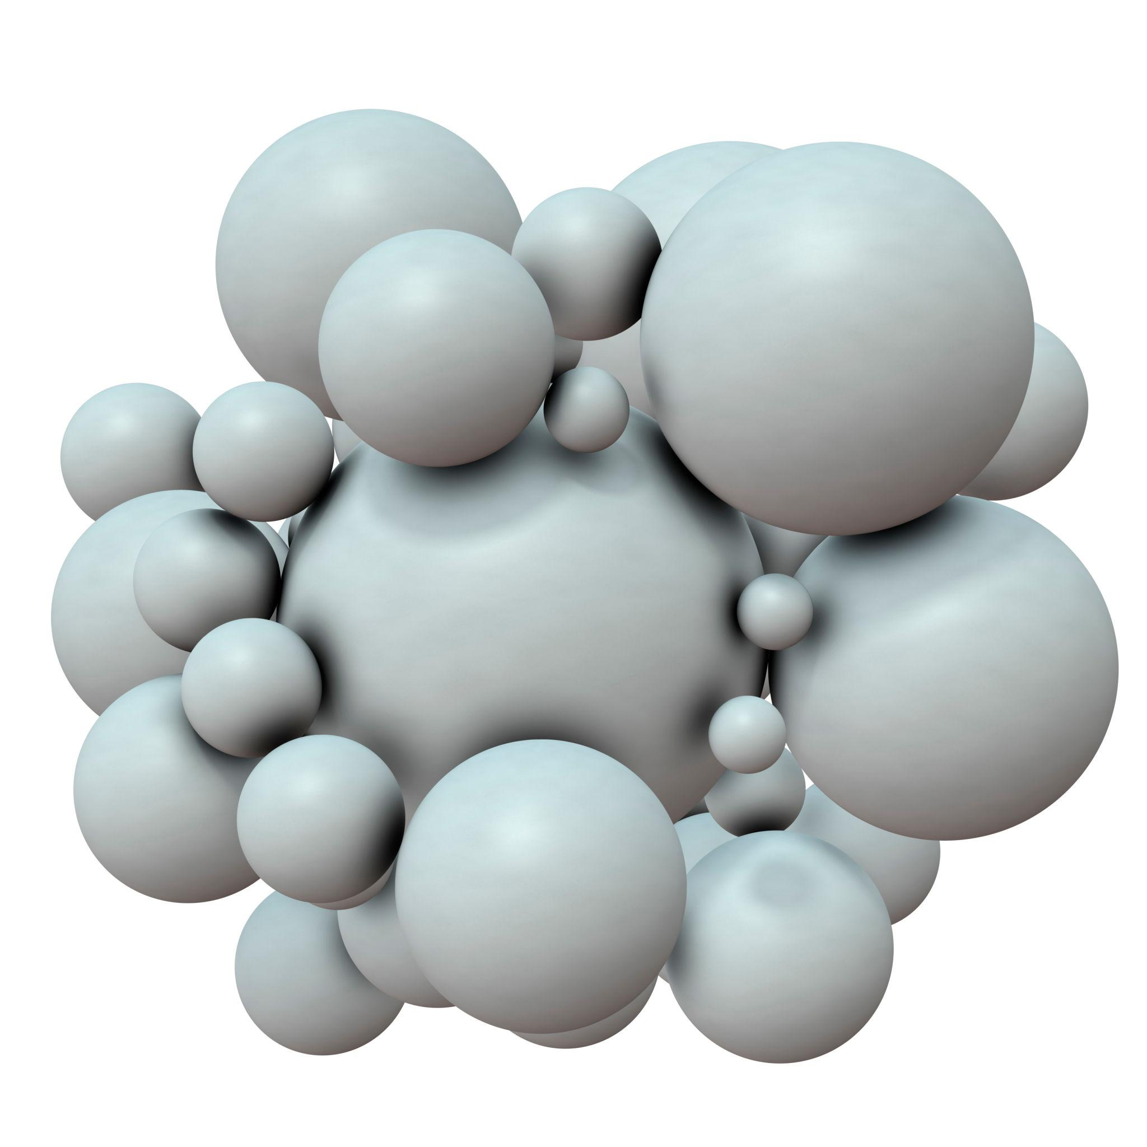
- All components are spheres.
- Their radii and diameters vary.
- Their volumes and surface areas differ.
- They may form irregular clusters or arrangements.
$$V_{i}=\frac{4}{3}πr_{i}^{3}$$
$${SA}_{i}=4πr_{i}^{2}$$

Non-Uniform Repeated Hemispheres
# Source: AI Source: Provided by: [Data Path: Persons Table -> ID Column: 1, Name_En Column: Motasem Essam] -> From: [ChatGPT] on [7/25/2026]
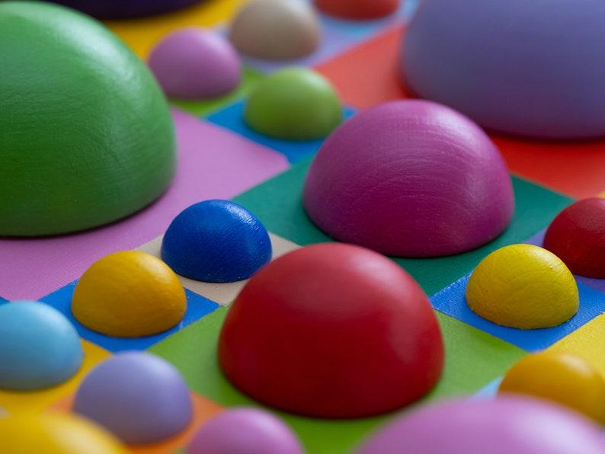
- All components are hemispheres.
- Their radii and diameters may vary irregularly.
- Their flat circular bases may have different areas.
- Their arrangement may be irregular or asymmetrical.
$$V_{i}=\frac{2}{3}πr_{i}^{3}$$
$${SA}_{i}=3πr_{i}^{2}$$
The surface area includes the curved surface and the flat circular base.

Classification by Dimensional Variation

Irregularly Increasing Dimensions
# Source: AI Source: Provided by: [Data Path: Persons Table -> ID Column: 1, Name_En Column: Motasem Essam] -> From: [ChatGPT] on [7/25/2026]
Component dimensions increase without maintaining a constant difference or ratio.
Example:
$$2, 3, 5, 9, 12 cm$$
The increases are:
$$1, 2, 4, 3 cm$$

Irregularly Decreasing Dimensions
# Source: AI Source: Provided by: [Data Path: Persons Table -> ID Column: 1, Name_En Column: Motasem Essam] -> From: [ChatGPT] on [7/25/2026]
Component dimensions decrease without following a constant difference or ratio.
Example:
$$15, 12, 8, 7, 3 cm$$

Independently Varying Dimensions
# Source: AI Source: Provided by: [Data Path: Persons Table -> ID Column: 1, Name_En Column: Motasem Essam] -> From: [ChatGPT] on [7/25/2026]
Different dimensions change independently rather than following one common relationship.
For example, rectangular prisms may have dimensions:
$$(2,3,4), (4,2,7), (3,6,5)$$

Unequal Proportional Relationships
# Source: AI Source: Provided by: [Data Path: Persons Table -> ID Column: 1, Name_En Column: Motasem Essam] -> From: [ChatGPT] on [7/25/2026]
Components may have the same geometric category but different proportions.
For example:
- Component A: $2×3×4$ cm.
- Component B: $3×4×7$ cm.
- Component C: $4×5×6$ cm.
There is no single scale factor connecting all corresponding dimensions.

Random Dimensional Variation
# Source: AI Source: Provided by: [Data Path: Persons Table -> ID Column: 1, Name_En Column: Motasem Essam] -> From: [ChatGPT] on [7/25/2026]
Component dimensions are selected without a predictable mathematical sequence.
Example:
$$3, 7, 4, 11, 6, 9 cm$$

Mixed Dimensional Variation
# Source: AI Source: Provided by: [Data Path: Persons Table -> ID Column: 1, Name_En Column: Motasem Essam] -> From: [ChatGPT] on [7/25/2026]
Several types of dimensional variation occur together.
For example:
- Some components increase in size.
- Other components decrease.
- Some components have different proportions.
- Other components vary in only one dimension.

Classification by Dimensional Consistency
# Source: AI Source: Provided by: [Data Path: Persons Table -> ID Column: 1, Name_En Column: Motasem Essam] -> From: [ChatGPT] on [7/25/2026]
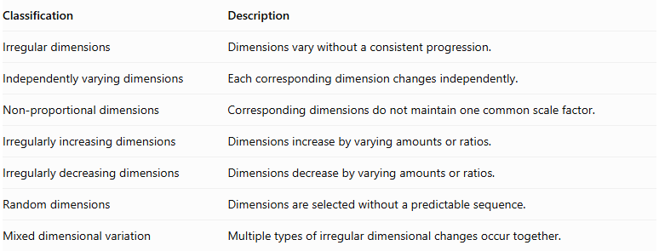
Classification | Description
Irregular dimensions | Dimensions vary without a consistent progression.
Independently varying dimensions | Each corresponding dimension changes independently.
Non-proportional dimensions | Corresponding dimensions do not maintain one common scale factor.
Irregularly increasing dimensions | Dimensions increase by varying amounts or ratios.
Irregularly decreasing dimensions | Dimensions decrease by varying amounts or ratios.
Random dimensions | Dimensions are selected without a predictable sequence.
Mixed dimensional variation | Multiple types of irregular dimensional changes occur together.

Classification by Repetition Arrangement
# Source: AI Source: Provided by: [Data Path: Persons Table -> ID Column: 1, Name_En Column: Motasem Essam] -> From: [ChatGPT] on [7/25/2026]
Non-uniform repeated components can be distributed through different spatial arrangements.
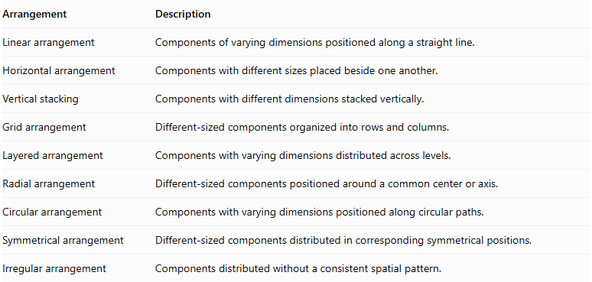
Arrangement | Description
Linear arrangement | Components of varying dimensions positioned along a straight line.
Horizontal arrangement | Components with different sizes placed beside one another.
Vertical stacking | Components with different dimensions stacked vertically.
Grid arrangement | Different-sized components organized into rows and columns.
Layered arrangement | Components with varying dimensions distributed across levels.
Radial arrangement | Different-sized components positioned around a common center or axis.
Circular arrangement | Components with varying dimensions positioned along circular paths.
Symmetrical arrangement | Different-sized components distributed in corresponding symmetrical positions.
Irregular arrangement | Components distributed without a consistent spatial pattern.

Mathematical Properties and Formulas

Total Number of Components
# Source: AI Source: Provided by: [Data Path: Persons Table -> ID Column: 1, Name_En Column: Motasem Essam] -> From: [ChatGPT] on [7/25/2026]
For $n$ repeated components:
$$\boxed{N=n}$$
For a three-dimensional grid:
$$\boxed{N=R×C×L}$$
Where:
- $R$ = Number of rows.
- $C$ = Number of columns.
- $L$ = Number of layers.

Total Volume
# Source: AI Source: Provided by: [Data Path: Persons Table -> ID Column: 1, Name_En Column: Motasem Essam] -> From: [ChatGPT] on [7/25/2026]
When components do not overlap internally:
$$\boxed{V_{total}=\sum_{i=1}^{n}{V_{i}}}$$
For cubes:
$$V_{total}=\sum_{i=1}^{n}{s_{i}^{3}}$$
For rectangular prisms:
$$V_{total}=\sum_{i=1}^{n}{l_{i}}$$
For cylinders:
$$V_{total}=\sum_{i=1}^{n}{π}r_{i}^{2}h_{i}$$

Total External Surface Area
# Source: AI Source: Provided by: [Data Path: Persons Table -> ID Column: 1, Name_En Column: Motasem Essam] -> From: [ChatGPT] on [7/25/2026]
For components joined through complete matching planar faces:
$$\boxed{{SA}_{total}=\sum_{i=1}^{n}{{SA}_{i}}-2\sum_{j=1}^{k}{A_{j}}}$$
Where:
- ${SA}_{i}$ = Surface area of component $i$.
- $A_{j}$ = Area of shared joining face $j$.
- $k$ = Number of shared face pairs.
For partial joining regions or curved intersections, the actual exposed surfaces must be calculated individually.

Average Component Dimension
# Source: AI Source: Provided by: [Data Path: Persons Table -> ID Column: 1, Name_En Column: Motasem Essam] -> From: [ChatGPT] on [7/25/2026]
For a selected corresponding dimension:
$$\boxed{barx=\frac{\sum_{i=1}^{n}{x_{i}}}{n}}$$
Where $x_{i}$ represents the dimension of component $i$.

Dimensional Range
# Source: AI Source: Provided by: [Data Path: Persons Table -> ID Column: 1, Name_En Column: Motasem Essam] -> From: [ChatGPT] on [7/25/2026]
The dimensional range measures the difference between the largest and smallest values.
$$\boxed{R=x_{max}-x_{min}}$$

Dimensional Variation
# Source: AI Source: Provided by: [Data Path: Persons Table -> ID Column: 1, Name_En Column: Motasem Essam] -> From: [ChatGPT] on [7/25/2026]
The population variance can describe how much a particular dimension varies across the components:
$$\boxed{σ^{2}=\frac{\sum_{i=1}^{n}{(}x_{i}-barx)^{2}}{n}}$$
This is a descriptive statistical measure, not a formula for calculating the composite solid's volume or surface area.

Worked Examples

Example 1: Cubes with Irregularly Varying Side Lengths
# Source: AI Source: Provided by: [Data Path: Persons Table -> ID Column: 1, Name_En Column: Motasem Essam] -> From: [ChatGPT] on [7/25/2026]
Given:
Four cubes are joined consecutively in a row.
Their side lengths are:
$$2, 3, 5, 7 cm$$
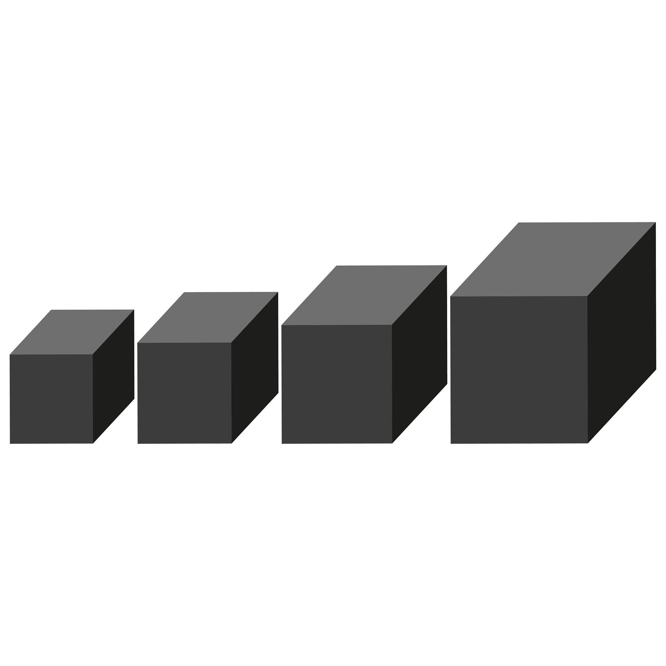
Step 1: Calculate the volume of each cube.
$$V_{1}=2^{3}=8{ cm}^{3}$$
$$V_{2}=3^{3}=27{ cm}^{3}$$
$$V_{3}=5^{3}=125{ cm}^{3}$$
$$V_{4}=7^{3}=343{ cm}^{3}$$
Step 2: Calculate the total volume.
$$V_{total}=8+27+125+343$$
$$\boxed{V_{total}=503{ cm}^{3}}$$
Step 3: Calculate the overall length.
Assuming consecutive placement without overlap:
$$L=2+3+5+7$$
$$\boxed{L=17 cm}$$
Step 4: Calculate the total external surface area.
Assume each successive cube is joined through a complete square region matching the smaller cube's face.
Individual surface areas:
$${SA}_{1}=6(2^{2})=24$$
$${SA}_{2}=6(3^{2})=54$$
$${SA}_{3}=6(5^{2})=150$$
$${SA}_{4}=6(7^{2})=294$$
Shared contact areas:
$$A_{1}=2^{2}=4$$
$$A_{2}=3^{2}=9$$
$$A_{3}=5^{2}=25$$
Therefore:
$${SA}_{total}=24+54+150+294-2(4+9+25)$$
$$=522-76$$
$$\boxed{{SA}_{total}=446{ cm}^{2}}$$

Example 2: Cylinders with Non-Uniform Dimensions
# Source: AI Source: Provided by: [Data Path: Persons Table -> ID Column: 1, Name_En Column: Motasem Essam] -> From: [ChatGPT] on [7/25/2026]
Given:
Three coaxial cylinders are stacked vertically.
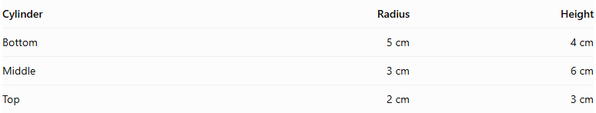
Cylinder | Radius | Height
Bottom | 5 cm | 4 cm
Middle | 3 cm | 6 cm
Top | 2 cm | 3 cm
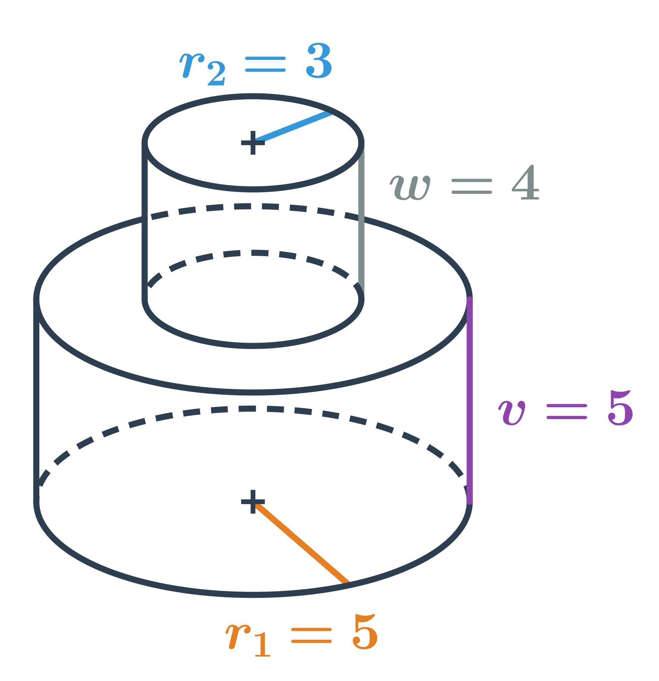
Step 1: Calculate the volume of each cylinder.
Bottom:
$$V_{1}=π(5)^{2}(4)=100π$$
Middle:
$$V_{2}=π(3)^{2}(6)=54π$$
Top:
$$V_{3}=π(2)^{2}(3)=12π$$
Step 2: Calculate the total volume.
$$V_{total}=100π+54π+12π$$
$$\boxed{V_{total}=166π≈521.50{ cm}^{3}}$$
Step 3: Calculate the total external surface area.
Individual surface areas:
$${SA}_{1}=2π(5)(5+4)=90π$$
$${SA}_{2}=2π(3)(3+6)=54π$$
$${SA}_{3}=2π(2)(2+3)=20π$$
The joining regions have radii 3 cm and 2 cm:
$$A_{1}=9π, A_{2}=4π$$
Therefore:
$${SA}_{total}=90π+54π+20π-2(9π+4π)$$
$$=164π-26π$$
$$\boxed{{SA}_{total}=138π≈433.54{ cm}^{2}}$$
The exposed annular portions of the larger cylinder bases remain visible.
Step 4: Calculate the overall height.
$$H=4+6+3$$
$$\boxed{H=13 cm}$$

Important Characteristics
# Source: AI Source: Provided by: [Data Path: Persons Table -> ID Column: 1, Name_En Column: Motasem Essam] -> From: [ChatGPT] on [7/25/2026]
- Repeated geometric category: Components belong to the same general geometric shape category.
- Irregular dimensional relationships: Their dimensions do not follow one consistent progression.
- Variable component sizes: Components may differ in one or several dimensions.
- Different individual volumes: Components generally have different volumes.
- Different individual surface areas: Their surface areas may vary.
- Flexible spatial arrangement: Components may be positioned in regular or irregular configurations.
- Variable joining regions: Contact areas depend on the dimensions and positions of the components.
- Irregular external boundaries: The final solid may have stepped, uneven, or asymmetrical boundaries.
- Independent geometric calculations: Each component's dimensions must be considered separately when calculating total volume and surface area.

Comparison with Related Classifications
# Source: AI Source: Provided by: [Data Path: Persons Table -> ID Column: 1, Name_En Column: Motasem Essam] -> From: [ChatGPT] on [7/25/2026]
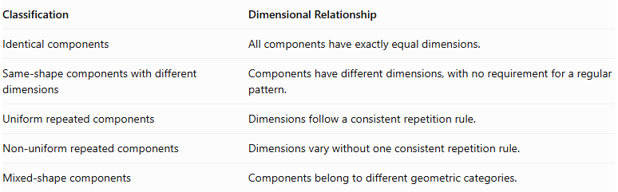
Classification | Dimensional Relationship
Identical components | All components have exactly equal dimensions.
Same-shape components with different dimensions | Components have different dimensions, with no requirement for a regular pattern.
Uniform repeated components | Dimensions follow a consistent repetition rule.
Non-uniform repeated components | Dimensions vary without one consistent repetition rule.
Mixed-shape components | Components belong to different geometric categories.
Important distinction:
- Uniform repeated components follow a predictable dimensional pattern.
- Non-uniform repeated components do not follow one consistent dimensional pattern.
- Both classifications may contain components of identical dimensions as a special case only when the repetition rule is constant; strictly non-uniform repetition requires actual variation.

Applications
# Source: AI Source: Provided by: [Data Path: Persons Table -> ID Column: 1, Name_En Column: Motasem Essam] -> From: [ChatGPT] on [7/25/2026]
- Architecture: Irregular structures made from blocks of the same shape but different sizes.
- Construction: Walls and structures built using differently sized blocks.
- Mechanical engineering: Assemblies with repeated cylindrical sections of varying dimensions.
- Manufacturing: Products assembled from components of the same shape but different specifications.
- Packaging: Groups of similarly shaped containers with different capacities.
- Mathematics: Problems involving irregular dimensional sequences, volume calculations, and external surface area.

Key Points
# Source: AI Source: Provided by: [Data Path: Persons Table -> ID Column: 1, Name_En Column: Motasem Essam] -> From: [ChatGPT] on [7/25/2026]
- Non-uniform repeated components belong to the same geometric category.
- Their dimensions vary without one consistent dimensional progression.
- Variations may be irregular, independent, non-proportional, or random.
- Total volume is the sum of individual volumes when there is no overlap.
- External surface area must account for hidden joining regions.
- Components may be arranged regularly or irregularly in space.
- This classification focuses on dimensional inconsistency rather than the spatial arrangement.

Conclusion
# Source: AI Source: Provided by: [Data Path: Persons Table -> ID Column: 1, Name_En Column: Motasem Essam] -> From: [ChatGPT] on [7/25/2026]
Non-uniform repeated components are used to form composite solids from repeated geometric shapes whose dimensions vary without following one consistent pattern. Unlike uniform repetition, their dimensional relationships may be irregular, independent, or non-proportional. This classification is useful for understanding complex structures containing repeated but differently sized geometric components.

